JAYITA MONDAL MITRA Mail ID : jayita21mondal@gmail.com
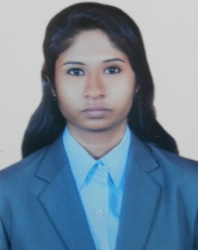
5/9 Dr. Umesh Mitra Road,
Budge Budge,
Kolkata – 700037
(Near Budge Budge Queen Cinema Hall)
Contac No.-+ (91) 7278093793

OBJECTIVE
A career that will enhance my educational, professional skills, experience and will provide ample opportunities for growth and a rewarding remuneration.

Personal Details
Date of Birth: 1st April 1988
Sex : Female

Guardian’s name : Prithwish Mitra

Marital Status: Married

Languages :

- English
- Hindi
- Bengali

Religion: Christianity

Nationality : Indian

Specialization: Major – Marketing
Minor – Finance
EDUCATION
Degree | Institute/ University | Discipline | Year of Passing | Aggregate
MBA | E.I.I.L.M. | Marketing/ Finance | 2014 | 65.76%
Graduation | Heramba Chandra College  Calcutta University | B Com (Financial Accounting) | 2009 | 59%
Higher Secondary | Brajamahan Tiwary Institution  W.B.C.H.S.E. | Commerce | 2006 | 65%
Secondary | U.C.N.I. Girls' High School  W.B.B.S.E. | General | 2004 | 71%

SKILLS
Computer
- M.S. Office
- Tally 9.0
- Ace 5

EXPERIENCE

Indusind Bank
- Position : Acquisition Manager
- Employment Period : October’14 to present
- Job Role : To deal with existing high end Credit Card
customers and upgrading their present
credit card to a premium segment of
card.

Internship
- Organization : ABP Pvt. Ltd.
- Duration : 2 Months.

PROJECTS
External
- Project Title : – Understanding The Readers Perception Towards English news paper and promoting The
Telegraph
- Organization : – ABP Pvt. Ltd.
- Duration : – 2 Months.

Internal
- Project Title : – LPG Autos in South Kolkata:
Profit Scenario and Demand- Supply Gap [Efficiency of green fuel for public transport in Kolkata]

HOBBIES AND PASSION
- Travel different places
- Listening to music
- Drawing (Hand work)

Place : Kolkata

Date :

JAYITA MONDAL

